**DETECTION**

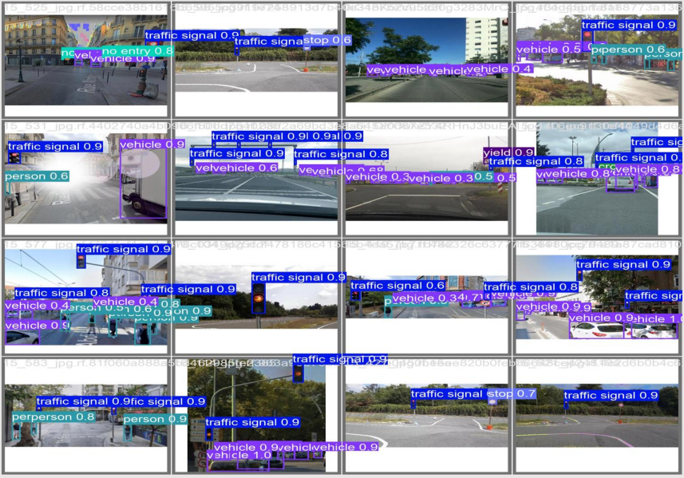

**SEGMENTATION**

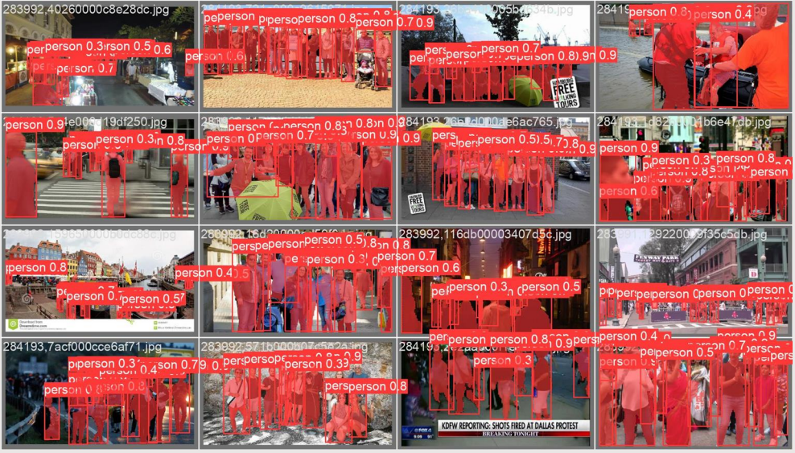

**CLASSIFICATION**

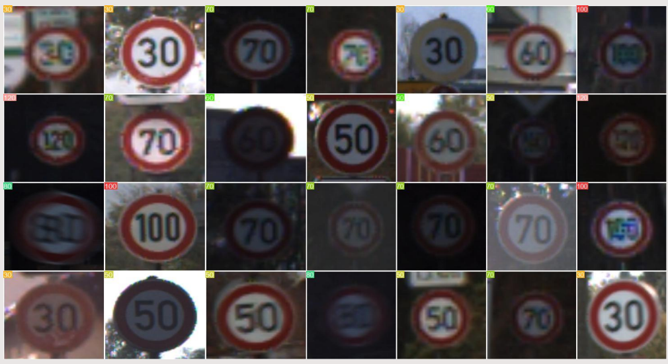

**HEADS-UP-DISPLAY**

